Collinearity

Definition
# Source: AI Source: Provided by: [Data Path: Persons Table -> ID Column: 1, Name_En Column: Motasem Essam] -> From: [ChatGPT] on [7/25/2026]
Collinearity is a geometric relationship in which two or more geometric objects, especially points, lie on the same straight line.
For points, three or more points are collinear if there exists a single straight line that contains all of them.
For example, if points $A$, $B$, and $C$all lie on line $l$:
$$A,B,C∈l$$
then $A$, $B$, and $C$are collinear.
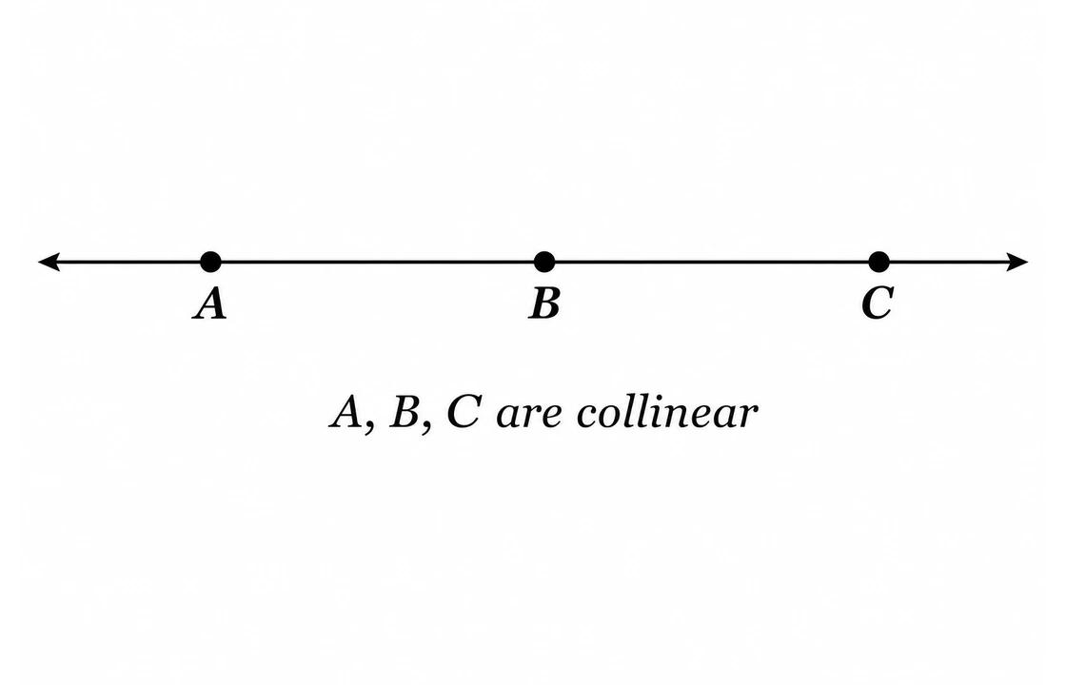
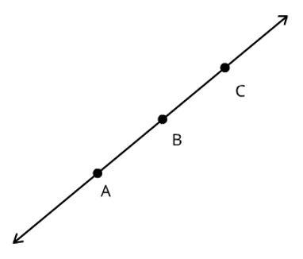
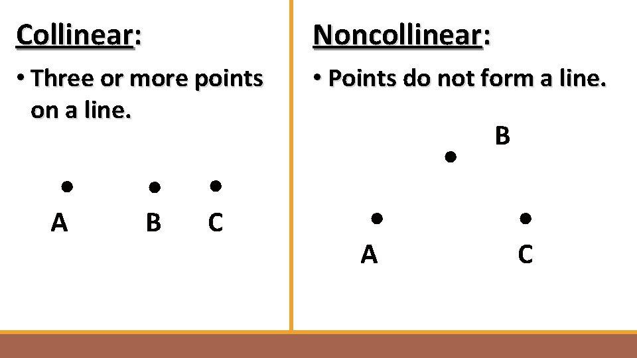
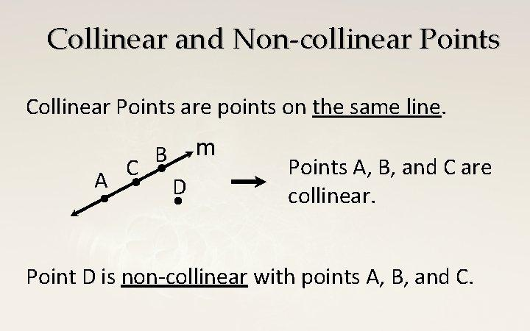
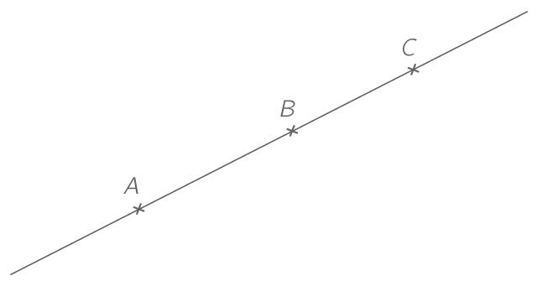

Purpose
# Source: AI Source: Provided by: [Data Path: Persons Table -> ID Column: 1, Name_En Column: Motasem Essam] -> From: [ChatGPT] on [7/25/2026]
Collinearity is used to:
- Determine whether points lie on the same straight line.
- Describe the alignment of geometric objects.
- Identify points belonging to the same line.
- Analyze line segments and their positional relationships.
- Establish geometric constructions and proofs.
- Define relationships such as collinear line segments.

Fundamental Concept
# Source: AI Source: Provided by: [Data Path: Persons Table -> ID Column: 1, Name_En Column: Motasem Essam] -> From: [ChatGPT] on [7/25/2026]
The central idea is:
All collinear points share one common straight line.
For points $A$, $B$, and $C$:
$$A,B,C\text{ are collinear}$$
if and only if there is a line $l$such that
$$A,B,C∈l$$
If no single straight line contains all the points, they are non-collinear.

Types of Collinearity
# Source: AI Source: Provided by: [Data Path: Persons Table -> ID Column: 1, Name_En Column: Motasem Essam] -> From: [ChatGPT] on [7/25/2026]
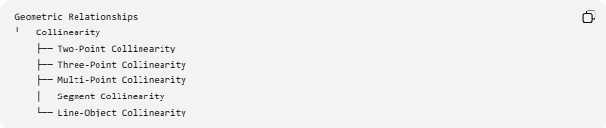
Geometric Relationships
└── Collinearity
├── Two-Point Collinearity
├── Three-Point Collinearity
├── Multi-Point Collinearity
├── Segment Collinearity
└── Line-Object Collinearity

1. Two-Point Collinearity
# Source: AI Source: Provided by: [Data Path: Persons Table -> ID Column: 1, Name_En Column: Motasem Essam] -> From: [ChatGPT] on [7/25/2026]
Any two distinct points determine exactly one straight line.
Therefore, two distinct points are always collinear.
Example:
$$A,B∈l$$
so $A$and $B$are collinear.

2. Three-Point Collinearity
# Source: AI Source: Provided by: [Data Path: Persons Table -> ID Column: 1, Name_En Column: Motasem Essam] -> From: [ChatGPT] on [7/25/2026]
Three points are collinear when they lie on the same straight line.
Example:
$$A,B,C∈l$$
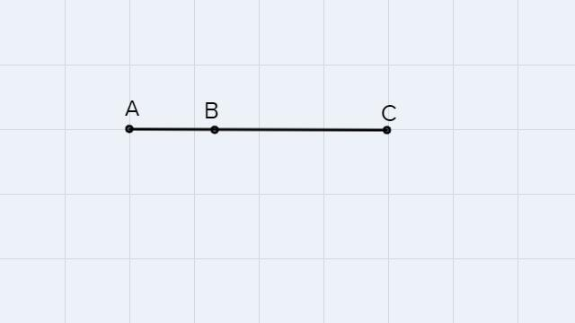
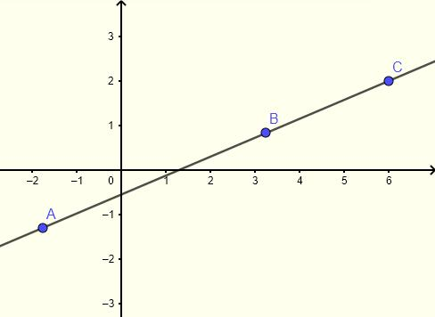
If the points form a triangle, they are not collinear.

3. Multi-Point Collinearity
# Source: AI Source: Provided by: [Data Path: Persons Table -> ID Column: 1, Name_En Column: Motasem Essam] -> From: [ChatGPT] on [7/25/2026]
Four or more points can also be collinear.
For example:
$$A,B,C,D,E∈l$$
All five points lie on the same line.
There is no theoretical limit to the number of points that can lie on one line.

4. Segment Collinearity
# Source: AI Source: Provided by: [Data Path: Persons Table -> ID Column: 1, Name_En Column: Motasem Essam] -> From: [ChatGPT] on [7/25/2026]
Two or more line segments are collinear when their supporting lines are the same line.
For segments $\overset{‾}{AB}$and $\overset{‾}{CD}$:
$$A,B,C,D∈l$$
means that both segments lie on the same straight line.
Their segments may be:
- separated,
- touching,
- overlapping, or
- coincident.
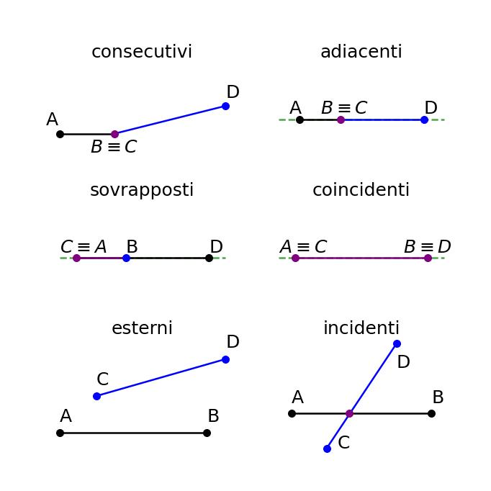
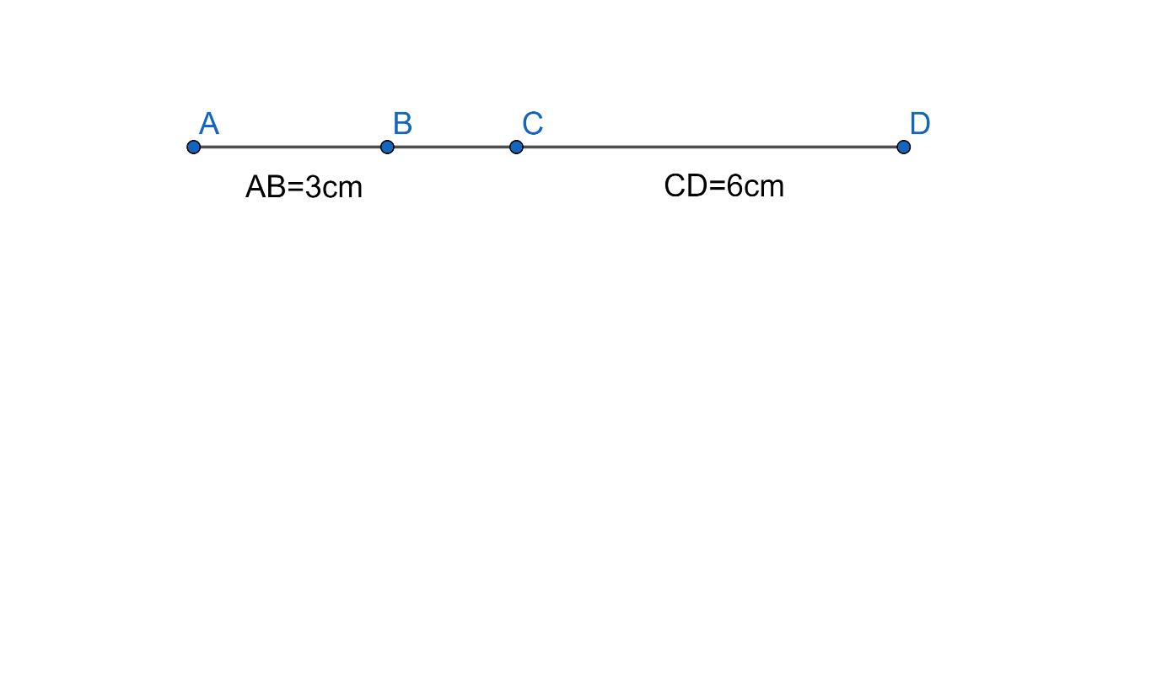
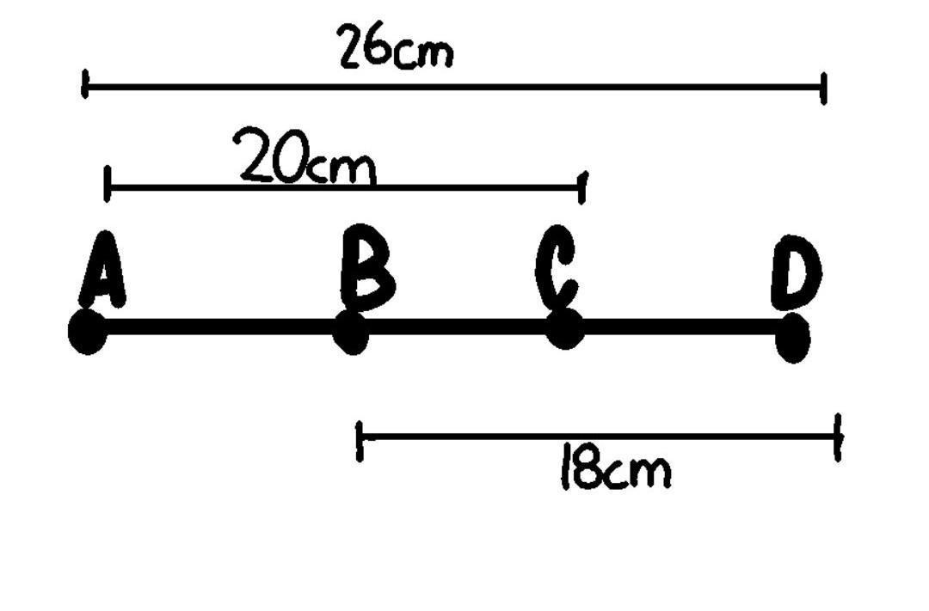

5. Line-Object Collinearity
# Source: AI Source: Provided by: [Data Path: Persons Table -> ID Column: 1, Name_En Column: Motasem Essam] -> From: [ChatGPT] on [7/25/2026]
Objects such as points and line segments can be aligned with the same supporting line.
For example:
$$P∈\overset{‾}{AB}$$
means that point $P$is collinear with $A$and $B$.
Thus:
$$A,P,B$$
are collinear.

Mathematical Tests for Collinearity

1. Coordinate Test Using Slope
# Source: AI Source: Provided by: [Data Path: Persons Table -> ID Column: 1, Name_En Column: Motasem Essam] -> From: [ChatGPT] on [7/25/2026]
For three points
$$A\left(x_{1} , y_{1}\right), B\left(x_{2} , y_{2}\right), C\left(x_{3} , y_{3}\right)$$
the points are collinear if their slopes are equal:
$$\frac{y_{2}-y_{1}}{x_{2}-x_{1}}=\frac{y_{3}-y_{1}}{x_{3}-x_{1}}$$
when the denominators are nonzero.
For vertical lines, the points are collinear when:
$$x_{1}=x_{2}=x_{3}$$

2. Determinant / Area Test
# Source: AI Source: Provided by: [Data Path: Persons Table -> ID Column: 1, Name_En Column: Motasem Essam] -> From: [ChatGPT] on [7/25/2026]
Three points are collinear if the area of the triangle formed by them is zero.
$$A_{△ABC}=0$$
The coordinate test can be written as:
$$\left(x_{2}-x_{1}\right)\left(y_{3}-y_{1}\right)-\left(y_{2}-y_{1}\right)\left(x_{3}-x_{1}\right)=0$$
Therefore:
$$\boxed{\left(x_{2}-x_{1}\right)\left(y_{3}-y_{1}\right)-\left(y_{2}-y_{1}\right)\left(x_{3}-x_{1}\right)=0}$$

Example
# Source: AI Source: Provided by: [Data Path: Persons Table -> ID Column: 1, Name_En Column: Motasem Essam] -> From: [ChatGPT] on [7/25/2026]
Consider:
$$A\left(1 , 2\right), B\left(4 , 5\right), C\left(7 , 8\right)$$
Calculate:
$$\left(x_{2}-x_{1}\right)\left(y_{3}-y_{1}\right)-\left(y_{2}-y_{1}\right)\left(x_{3}-x_{1}\right) \\ =\left(4-1\right)\left(8-2\right)-\left(5-2\right)\left(7-1\right) \\ =3\left(6\right)-3\left(6\right) \\ =18-18=0$$
Therefore:
$$\boxed{A,B,C\text{ are collinear}}$$

Collinearity vs. Non-Collinearity
# Source: AI Source: Provided by: [Data Path: Persons Table -> ID Column: 1, Name_En Column: Motasem Essam] -> From: [ChatGPT] on [7/25/2026]
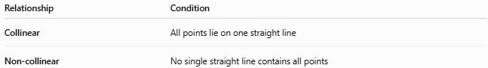
Relationship | Condition
Collinear | All points lie on one straight line
Non-collinear | No single straight line contains all points
For three points:
$$\text{Collinear }⟺ A_{△ABC}=0 \\ \text{Non-collinear }⟺ A_{△ABC}≠0$$

Collinearity vs. Related Relationships
# Source: AI Source: Provided by: [Data Path: Persons Table -> ID Column: 1, Name_En Column: Motasem Essam] -> From: [ChatGPT] on [7/25/2026]
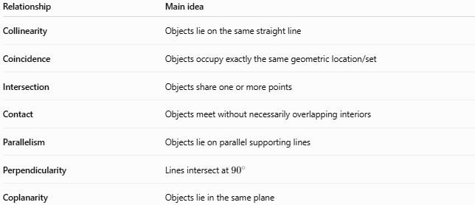
Relationship | Main idea
Collinearity | Objects lie on the same straight line
Coincidence | Objects occupy exactly the same geometric location/set
Intersection | Objects share one or more points
Contact | Objects meet without necessarily overlapping interiors
Parallelism | Objects lie on parallel supporting lines
Perpendicularity | Lines intersect at ${90}^{∘}$
Coplanarity | Objects lie in the same plane
Important distinction
Collinearity is stronger than simple intersection.
Two lines can intersect at one point without being collinear.
For example:
$$l_{1}∩l_{2}=P$$
does not mean $l_{1}$and $l_{2}$are collinear.
Two distinct lines are collinear only when they are actually the same line.

Important Properties
# Source: AI Source: Provided by: [Data Path: Persons Table -> ID Column: 1, Name_En Column: Motasem Essam] -> From: [ChatGPT] on [7/25/2026]
- Any two distinct points determine a unique line.
- Any two distinct points are therefore collinear.
- Three or more points may or may not be collinear.
- Collinear points can lie between one another or outside one another.
- Collinearity does not require the points to be adjacent.
- Collinear segments may be separated or may overlap.
- Three non-collinear points determine a triangle.
- Three collinear points cannot form a non-degenerate triangle.

Example of Different Arrangements
# Source: AI Source: Provided by: [Data Path: Persons Table -> ID Column: 1, Name_En Column: Motasem Essam] -> From: [ChatGPT] on [7/25/2026]

Collinear:

A -------- B -------- C

Collinear:

A -------- C
B

Non-collinear:

A
\
\
B
\
C
In the first two cases, $A,B,C$are collinear. In the last case, they are non-collinear.

Key Points
# Source: AI Source: Provided by: [Data Path: Persons Table -> ID Column: 1, Name_En Column: Motasem Essam] -> From: [ChatGPT] on [7/25/2026]
- Collinearity = lying on the same straight line.
- It is most commonly applied to points.
- Two distinct points are always collinear.
- Three or more points must be tested for collinearity.
- Zero triangle area indicates collinearity.
- In coordinates, the determinant expression equal to zero is a reliable test.
- Collinearity is different from coincidence, intersection, and parallelism.
- Collinear Line Segments are segments whose supporting lines are the same line.

Conclusion
# Source: AI Source: Provided by: [Data Path: Persons Table -> ID Column: 1, Name_En Column: Motasem Essam] -> From: [ChatGPT] on [7/25/2026]
Collinearity is a fundamental geometric relationship describing the alignment of two or more geometric objects along one straight line. It provides the basis for analyzing point alignment, line segments, intersections, geometric constructions, and coordinate geometry.

